22.11: But the box is symmetrical, so for one side, the flux is: 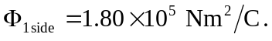
b) No change. Charge enclosed is the same.

